

**Applied Physics for**

**Scientists and**

**Engineers**

**To ﬁnd the Temperature coef ﬁcient of Resistance of a Coil using Wheatstone Bridge:**

**Submitted to:**

Sir. Haseen Ullah Jan

**Submitted by**

Muhammad Sadeeq Computer System engineering FALL 2021

Sec. C Roll No. 75025

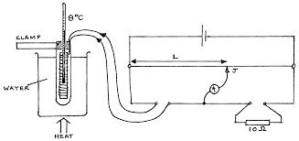

o o

o

**Introduction & Background**

Temperature coef ﬁcient of resistance is the measure of change in electrical resistance of any substance per degree of temperature change. Let us take a conductor having a resistance of R0 at 0 C and Rt at t C respectively. This αo is called temperature

coef ﬁcient of resistance of that substance at 0 C.



**Apparatus:**

Following apparatus is used to carry out this demonstration:

1. Coil
2. Water
3. Keys
4. Thermometer
5. Wheatstone Bridge
6. H.R.B
7. Galvanometer

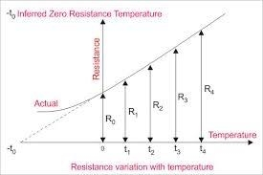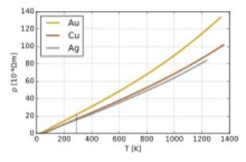

**Procedure:**

Following procedure is needed to be followed:

1. First of all connections of galvanometer and whole apparatus. Then the

deﬂection of galvanometer is read as maximum.

1. Some of resistance is plugged out of P and Q noting that P>Q to bring deﬂection on scale.
2. Resistance is decreased or increased to bring galvanometer to zero point.
3. Value of temperature T1 is taken and Rt is calculated by the formula given below;

R=

*Qx R*

*P*

1. Then the water is boiled and Rt2 is calculated.
2. Value of temperature is noted.

**Conclusion:**

Following conclusions are concluded:

1. Resistance of copper wire increased with temperature.
2. Temperature coef ﬁcient of resistance for the given copper wire was in range between 0.0038 ohm to 0.0057 ohm.



**Readings:**

|  |  |  |  |  |  |  |  |  |
| --- | --- | --- | --- | --- | --- | --- | --- | --- |
| S.No | T1 | T2 | P in ohms | Q in Ohms | R  in Ohms | Rt1=  *Q x R*  *P* | Rt2=  *Q x R* | α=  *Rt* 2 − *Rt* 1  *Rt* 1( *t*1) −*Rt* 2(*t*10 |
| 1. | 40 | 70 | 1000 | 100 | 200 | 20 | 22 | 2/50=0.003  8 |
| 2. | 60 | 80 | 100 | 10 | 210 | 21 | 22.5 | 2.5/435=0.  0057 |
| 3. | 32 | 85 | 1000 | 10 | 900 | 9 | 11.19 | 2.19/379.9  2=0.00576 |
| 4. | 42 | 56 | 1000 | 100 | 205 | 20.5 | 23 | 2.5/601=0.  0041 |